DOCUMENTATION

theil-sen_estimator

CONTENTS

Explanation of what this program finally does 3

What does this program do and consist of? 4

# Explanation of what this program finally does

In this program we do hypothesis testing, draw linear regression model, use Theil-Sen estimator and find confidence interval for this estimation.

As we know, equation that describes linear regression is

$$y = kx + b,$$

where k – slope,

b – intercept.

So, null hypothesis that we test is that slope is equal to zero, and alternative hypothesis is that slope is not equal to zero:

$$H_{0}: slope=0; H_{A}: slope≠0$$

# What does this program do and consist of?

All functionality is defined in Slope_Regression class, in main function we call some methods of this class to accomplish our purposes (figure 1).

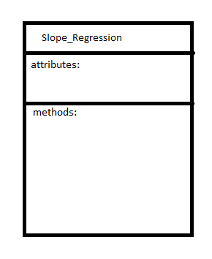  
Figure 1 – Algorithm of the program

In DataRead() method we get, print out and "remember" input data.

In IsEqualHypothesis() method we find differences of actual and expected y if slope equals to zero, count number of elements in dif array (or D[j]-D[i]), create dif array, use c(D[j]-D[i]) function and "remember" all necessary data.

Then we call PrintOutHypothesis() method to print out all calculations.

TheilSenEsimator(alpha) method takes alpha as a confidence level, then prints out and returns Theil-Sen estimation. This estimation is used in Draw() method to plot fitted line and compare it to simple linear regression.

In main function you can choose what method of Slope_Regression class to use.